**MAJOR PROJECT**

**WINE QUALITY ANALYSIS**

**Aim:**

To use machine learning to predict the quality of wine based on its chemical properties, such as acidity, pH, and alcohol content. By analysing these features, the goal is to develop models that can classify wine quality into categories (like poor, average, or excellent) and also predict its quality score on a scale.

**Code:**

import numpy as np

import pandas as pd

import matplotlib.pyplot as plt

import seaborn as sns

import warnings

warnings.filterwarnings('ignore')

df = pd.read_csv(r'C:\Users\yogesh\Downloads\upload_b17b4ebe-b5ef-4168-b23e-759428717a8b.csv')

df.head()

from sklearn.impute import KNNImputer

from sklearn.model_selection import train_test_split

from sklearn.preprocessing import MinMaxScaler

from sklearn.linear_model import LogisticRegression

from sklearn.compose import ColumnTransformer

from sklearn.pipeline import Pipeline

from sklearn.metrics import classification_report

from xgboost import XGBClassifier

from sklearn.ensemble import RandomForestClassifier

df.info()

df.describe().T

print(df.isnull().sum())

imputer = KNNImputer(n_neighbors=3)

df_imputed = pd.DataFrame(imputer.fit_transform(df), columns=df.columns)

for col in df_imputed.columns:

plt.figure(figsize=(14, 4))

plt.title(f'Distribution and Boxplot for {col}')

plt.subplot(1, 2, 1)

sns.distplot(df_imputed[col])

plt.subplot(1, 2, 2)

sns.boxplot(df_imputed[col])

plt.show()

for col in df_imputed.columns:

percentile25 = df_imputed[col].quantile(0.25)

percentile75 = df_imputed[col].quantile(0.75)

IQR = percentile75 - percentile25

upper_limit = percentile75 + 1.5 * IQR

lower_limit = percentile25 - 1.5 * IQR

df_imputed[col] = np.where(df_imputed[col] > upper_limit, upper_limit,

np.where(df_imputed[col] < lower_limit, lower_limit, df_imputed[col]))

df_imputed['best_quality'] = [1 if x > 5 else 0 for x in df_imputed['quality']]

df_imputed.drop(columns=['quality'], inplace=True)

plt.figure(figsize=(20, 10))

sns.heatmap(df_imputed.corr(), annot=True, cmap='coolwarm', fmt=".2f", linewidths=0.5)

plt.show()

X = df_imputed.drop(columns=['best_quality'])

y = df_imputed['best_quality']

X_train, X_test, y_train, y_test = train_test_split(X, y, test_size=0.2, random_state=42)

trf1 = ColumnTransformer([('scaler', MinMaxScaler(), slice(0, 12))], remainder='passthrough')

pipe = Pipeline([('trf1', trf1)])

X_train_transform = pipe.fit_transform(X_train)

X_test_transform = pipe.traQQnsform(X_test)

models = {

'Logistic Regression': LogisticRegression(),

'XGBoost': XGBClassifier(use_label_encoder=False, eval_metric='mlogloss'), # Fixed typo

'Random Forest': RandomForestClassifier()

}

for name, model in models.items():

model.fit(X_train_transform, y_train)

y_pred = model.predict(X_test_transform)

cl_report = classification_report(y_test, y_pred)

print(f'Classification Report for {name}:\n\n{cl_report}')

**Output:**

1. Fixed Acidity: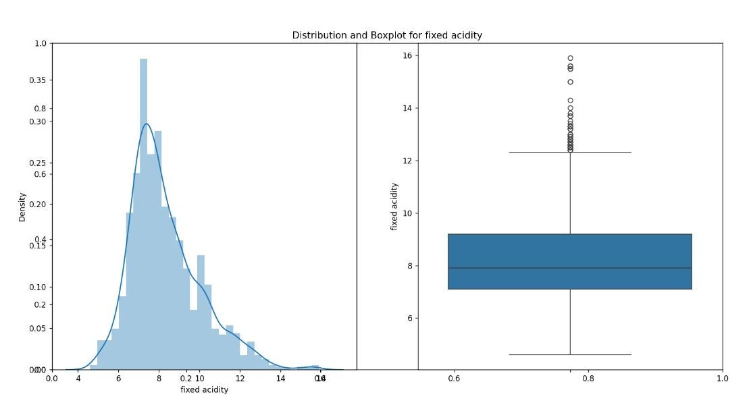
2. Volatile Acidity:

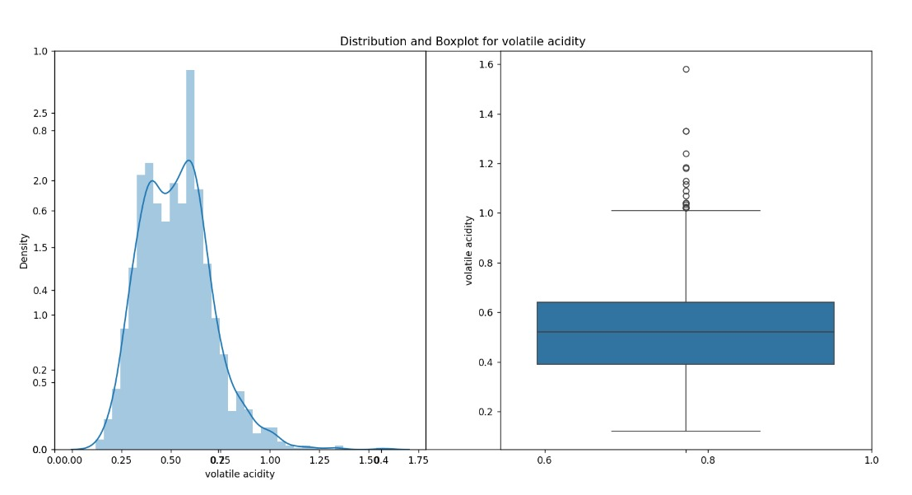

1. Citric Acid:

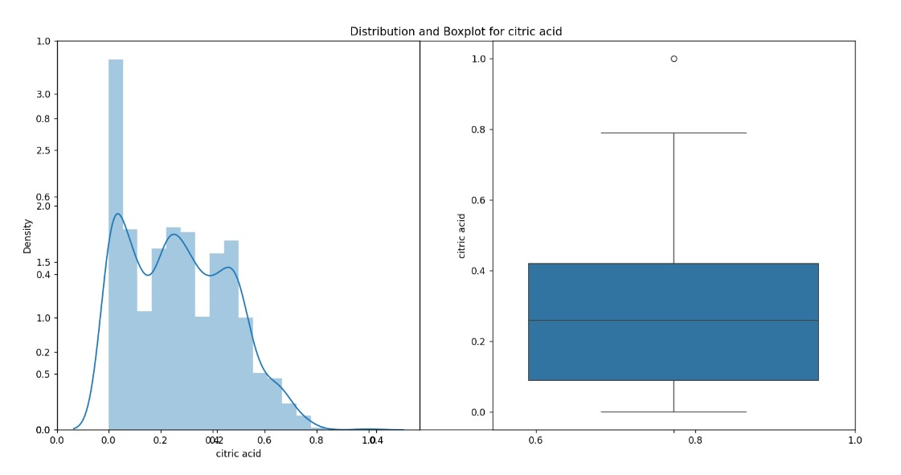

1. Residual Sugar:

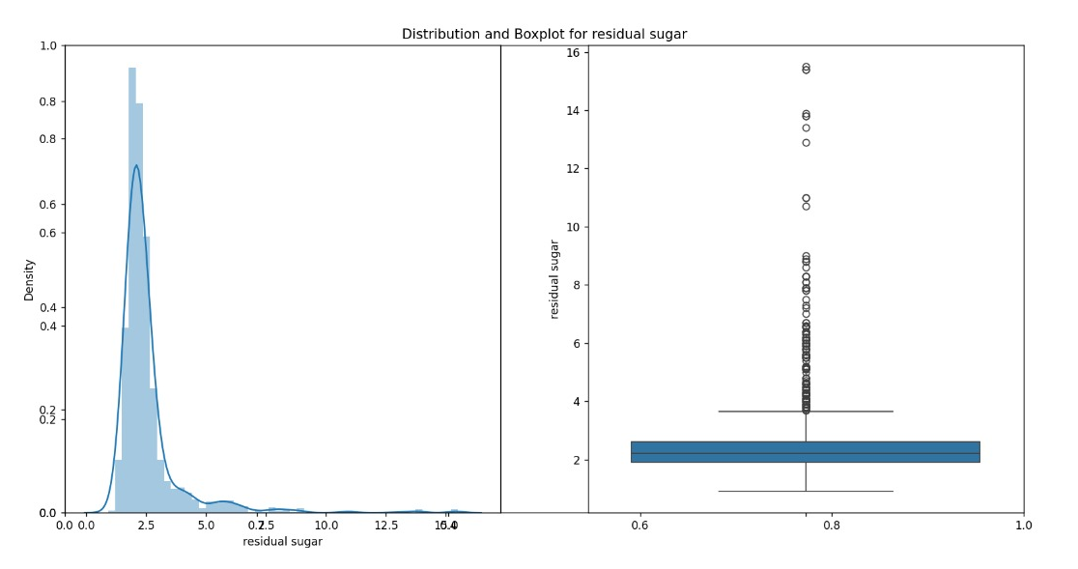

1. Chlorides:

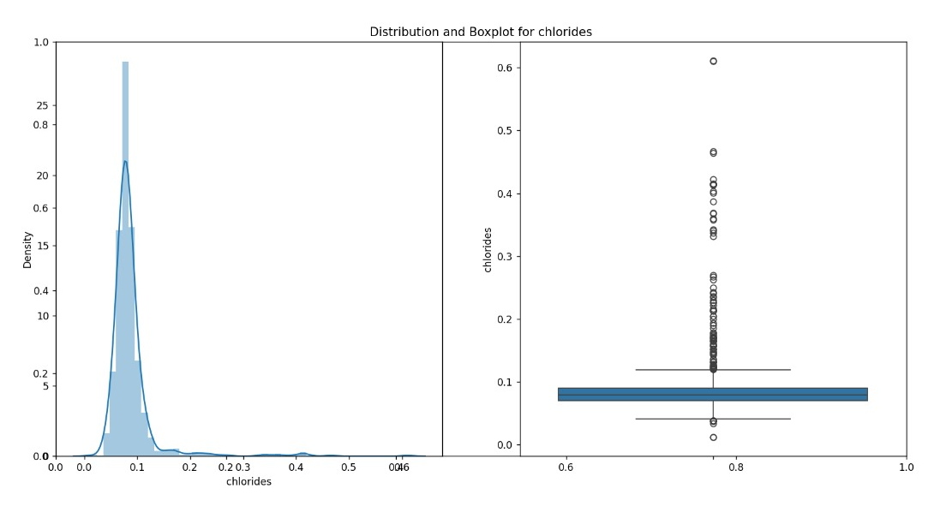

1. Free Sulfur Dioxide:

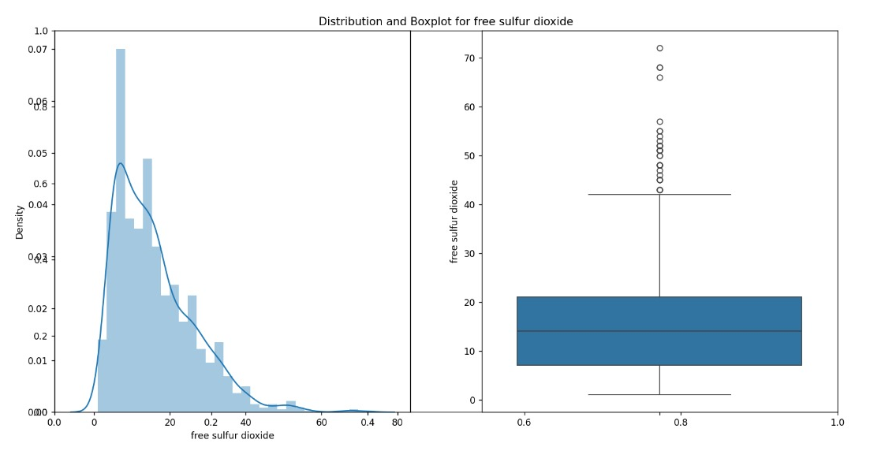

1. Total Sulfur Dioxide:

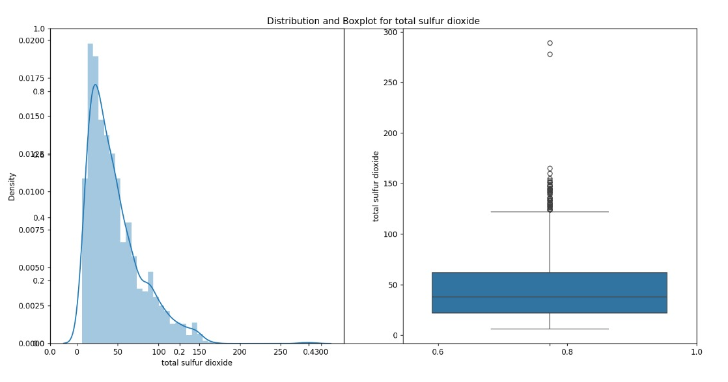

1. Density:

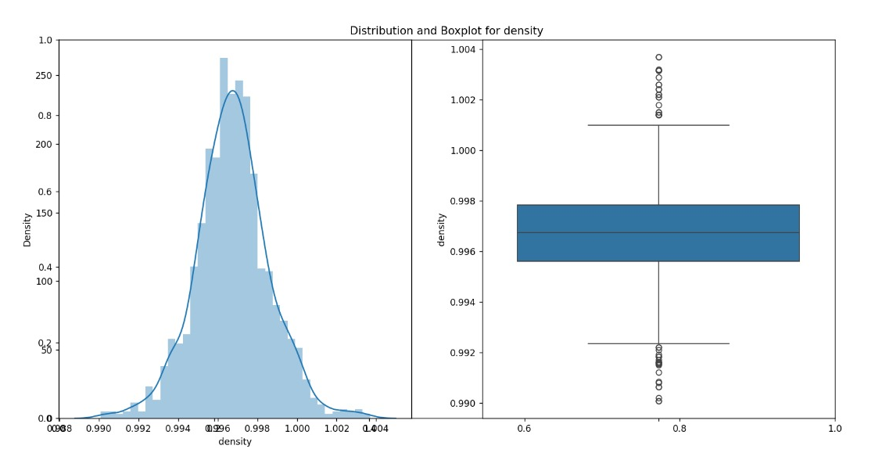

1. pH:

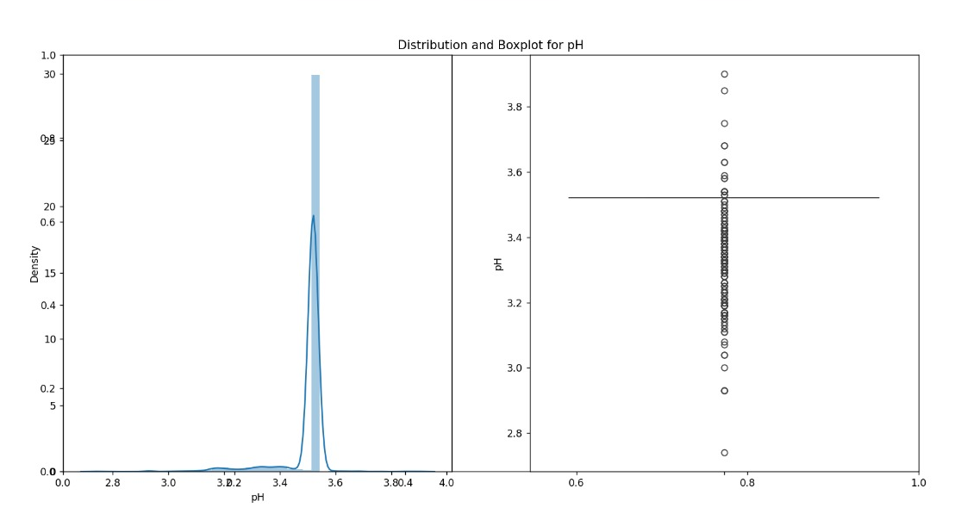

10.Sulphates: 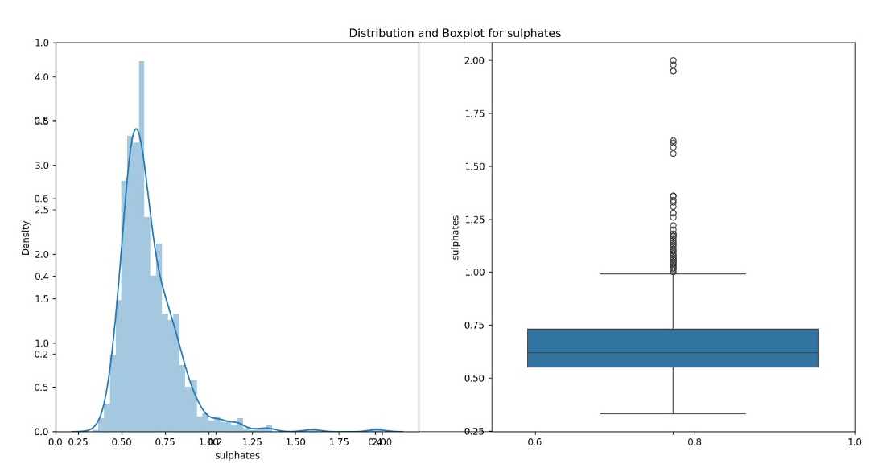

11.Alcohol: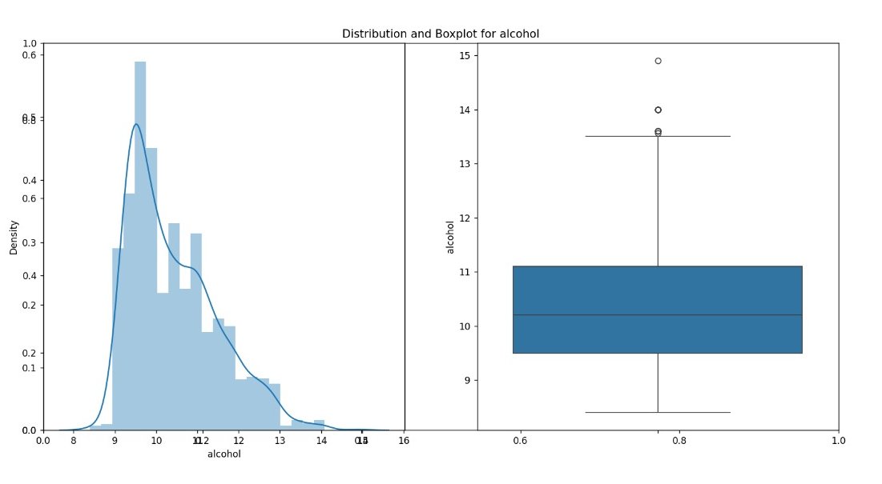

12. Quality (score between o and10):

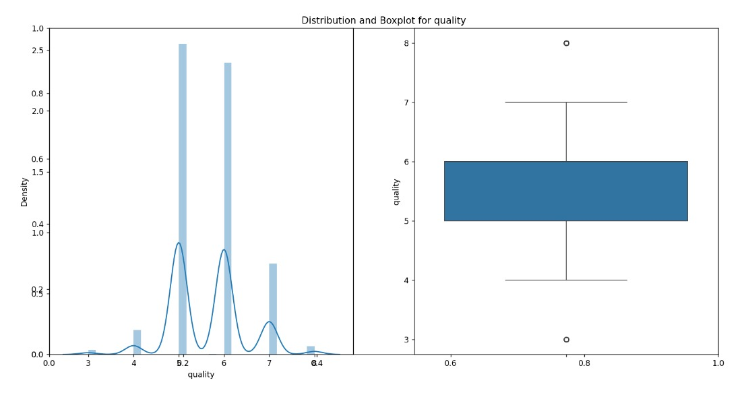

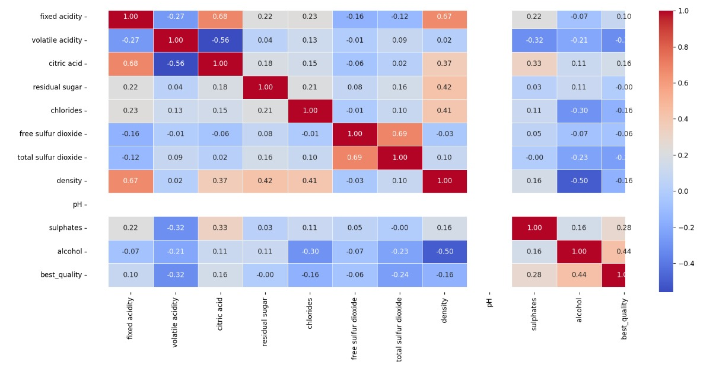

**TEAM NUMBER: 8**

**TEAM MEMBERS:**

S. Bhuwaneshwari

Yogesh S

Likitha.M

Bhoomika MS